|  |  |  |  |
| --- | --- | --- | --- |
| 1 | | 49,262 | |
| **NUMERO DE FRONTERAS** | | **ENERGIA AGREGADA** | |
|  | | | |
| 27,419,681 | 73 | | 1,140,115 |
| INGRESO 2020 | DÍAS CERTIFICADOS 2020 | | ENERGIA RESPALDADA 2020 |
|  | | | |
| 25,475,715 | 37 | | 1,119,406 |
| INGRESO 2021 | DÍAS CERTIFICADOS 2021 | | ENERGIA RESPALDADA 2021 |

**HISTORICO REINTEGRO DDV**

|  |  |  |
| --- | --- | --- |
|  | **2020** | **2021** |
| **ENE** | - | 2.81 |
| **FEB** | - | - |
| **MAR** | - | - |
| **ABR** | - | - |
| **MAY** | - | 20.43 |
| **JUN** | - | 2.24 |
| **JUL** | - | - |
| **AGO** | 13.44 | - |
| **SEP** | 3.66 | - |
| **OCT** | 3.51 | - |
| **NOV** | 2.38 | - |
| **DIC** | 4.44 | - |

**Los valores de la tabla están en millones de COP**



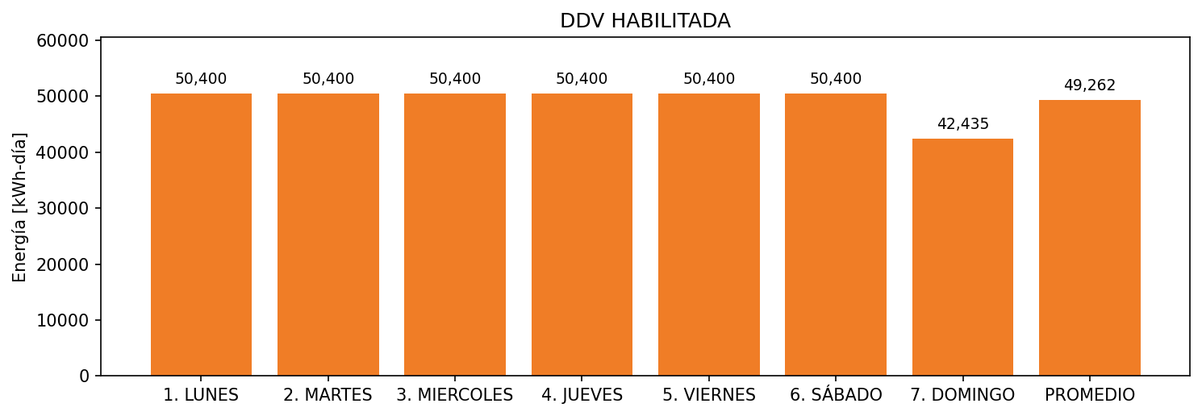

|  |  |  |  |  |  |  |  |  |  |
| --- | --- | --- | --- | --- | --- | --- | --- | --- | --- |
| **FRONTERA** | **COD SIC** | **FRT DDV** | **TIPO DDV** | **PROMEDIO** | **PRÓXIMA ACTUALIZACIÓN** | **MARGEN DE ERROR** | **ÚLTIMA PRUEBA DDV** | **DÍAS PARTICIPACIÓN** | **FECHA REFERENCIA PRÓXIMA PRUEBA DDV** |
| PRODUCTOS SANITARIOS SANCELA S.A. | Frt00607 | Frt38318 | LBC | 49,262 | 2022-02-17 | 3,81 | 2021-04-03 | 24.0 | 2022-02-17 |